
School Nursing Newsletter
Summer 2026

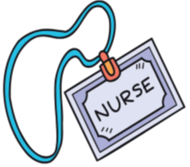


As we move into the summer term, it’s a valuable time to reflect on the health & wellbeing of our children & young people, while supporting families to stay safe, active & well over the holidays.




Our School Nursing teams continue to carry out P1 and Year 8 Health appraisals during the summer term. Please check your child’s school bag for the consent forms and return them to school. ASAP.





Health & Wellbeing

Walking to and from school is a simple way to build daily physical activity into your child’s routine.

Just a short walk each day can:

- Boost physical health & fitness
- Support mental health
- Improve focus and readiness to learn

Even parking a short distance away from the school and walking the last few minutes with your child can make a difference. Give it a go, every step counts!

For further information please see: www.livingstreets.org.uk








National smile month between May & June is a great reminder to support your child’s oral health every day.

Top tips for health teeth:
- Brush teeth twice daily with fluoride toothpaste
- Cut down on sugary snacks & drinks
- Visit the dentist regularly
For further information please see: National Smile Month
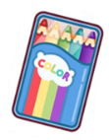

Oral Health

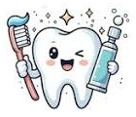


1




Farm Safety

Farm safety week is approaching in July, it is a key reminder of the importance of keeping children and young people safe around farms.

Farms can be exciting places, but they also have many risks.

Top safety reminders:

- Children and young people should always be supervised around farmyards and machinery.
- Keep well away from moving vehicles and equipment
- Never play in or near silos, slurry tank or chemicals
- Ensure hands are washed with soap and water after handling animals and their surroundings.

For further information please see: Farm Safety Week HSENI

Parents and carers – Please take time to talk about farm safety at home – safety starts with awareness.







Other Health Information and advice:










Protect your child’s skin!

As we move into our summer term, its important to remind families about keeping children safe in the sun.

Even in the UK & Ireland, UV rays can cause sunburn and long-term skin damage.

Top sun safety tips:

- Apply suncream with high SPF and UVA protection that is fragrance-free, to reduce the risk of allergic reactions

- Wear a hat and protective clothing on sunny days.

- Encourage ‘Shade Breaks’, especially at lunchtime.

- Stay hydrated with plenty of water.

A few simple steps help protect your child’s skin now and in the future.

For further information please see: Sun Awareness Week

Sun Safety





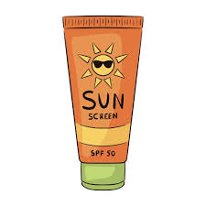






2
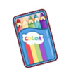

Please check those school bags!

The School Immunisation Team are continuing to offer all young people in years 9 & 10 the opportunity to receive the Human Papillomavirus (HPV) vaccine. This vaccine helps protect against HPV and those cancers related to the virus.

The vaccine is given as a single injection into the upper arm, and is offered to both boys and girls.

Your child will have received a consent form through school and it is important that these are returned as soon as possible.

For further information please see: https://vimeo.com/826165871/139517d316

Flu vaccination information and consent forms will be sent home in Primary & Post-Primary aged pupils school bags from September 2026. Please check your child’s bag regularly.

The flu vaccination helps protect your child and those around them from the flu virus.

Even if you do not wish your child to receive the vaccination, we still need the form to be returned please.
Vaccinations Update:
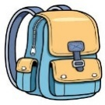
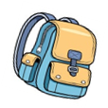







April:

22 - 28 Apr – National Allergies Week - www.allergyuk.org
24-30 Apr - World Immunisation Week - World Immunization Week

May:

4 - 15 May – Talk Pants Fortnight - NSPCC
11 - 17 May – Sun Awareness Week - Sun Awareness Week
19 – 23 May – Walk to School Week - www.livingstreets.org.uk
11 – 15 May – Weaning Week – Your baby's first solid foods
12 May – 12 June – National Smile Month - National Smile Month

June:

1 – 7 Jun – Child Safety Week – Child Safety Week
8 – 14 Jun – IMH Awareness Week – Parent-Infant Foundation
16 – 22 Jun – World Continence Week - Children – Bladder & Bowel

July:

1 – 31 Jul – Respect the water campaign – Water Safety RNLI
20 – 24 Jul – Farm Safety Week - Farm Safety Week HSENI



Events





3

Keeping young people safe online matters to us. That’s why digital safety will remain a regular feature in our newsletter, giving you ongoing access to helpful resources and advice.

Online Safety Hub - Safeguarding Board for Northern Ireland

Have a conversation | Childnet

Internet-Matters-Age-Guide-6-10s-Jan23.pdf

Internet-Matters-Age-Guide-11-13-Jan23.pdf

Internet-Matters-Age-Guide-14plus-Jan23.pdf

How to talk to children about keeping safe online | Barnardo's

Digital Safety


“Thank you for your continued support in keeping our children and young people healthy happy and safe. Together, we can encourage healthy lifestyle choices improving the health and wellbeing of our children and young people.”

If you have any questions about your child’s health, vaccination programmes, or would like advice, please contact the School Nursing Team via the numbers in the link.
Please use the link below:
School Nursing Service - Northern Health and Social Care Trust

Or scan the QR to connect to the NHSCT website:
How to contact us:







Please share your experiences of School Nursing in NHSCT via the link below.
Care Opinion
4

