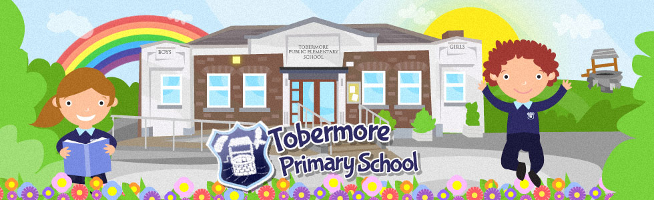

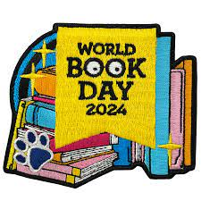
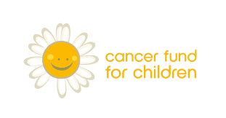

Dear Parent/Guardian

To celebrate World Book Day 2024 the children in Tobermore Primary School are taking part in a, ‘ReadOn School Reading Initiative’ in partnership with Cancer Fund for Children. Each child in P3-P7 (P1 & P2 see attached note) has already chosen their own reading challenge in class, whether they decide to read an extra chapter each day, or an extra book in five days, or read to a family member for 15 minutes each day (see back of enclosed book mark), every bit of extra reading counts! The challenge will begin on Wednesday 28th February and end on Friday 15th March and we would encourage all children to ask family and friends for sponsorship throughout the Readon challenge (see enclosed sponsorship leaflet). There are also prizes for, ‘Top Fundraising Pupil’ or ‘Top Reader’ in each school.

All money raised must be returned to school (along with sponsorship form) by Friday 15th March. All money will go to this very worthy cause, supporting children and young people impacted by a cancer diagnosis, something which has touched our own school community recently.

Any child wishing to dress up for world book day may do so on Friday 15th March. Those not wishing to dress up may bring along a favourite book and talk about what they did for their ‘Readon’ challenge.

Many Thanks
Student Council and Mrs Speers

