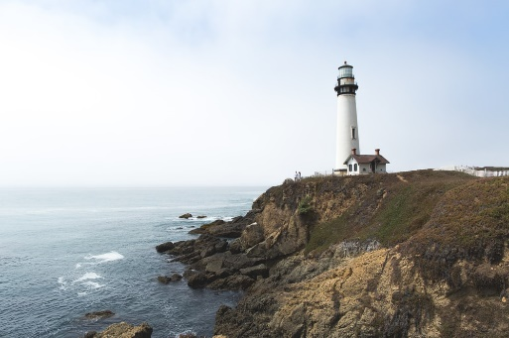
My Lighthouse
My Lighthouse…
Protects me from all danger every day and night;
Makes me laugh when I am sad;
Provides me with good advice so I can make the right decisions;
Helps me try new things;
Calms me down when I have a scary nightmare;
Plays with me when I am bored or lonely;
Is proud of me when I try my best;
Talks to me when I am troubled;
Takes me to my happy place every single day;
Looks after me when I feel lost.

My Lighthouse is Kacey-Lee

By Courtney Donaldson

