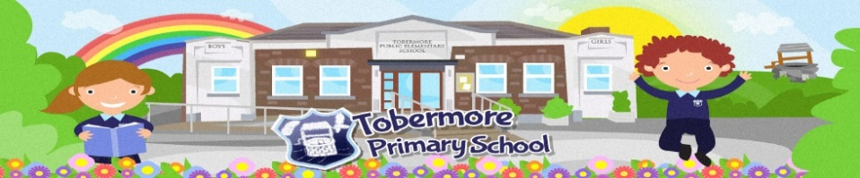

Tobermore Primary School Student Council Agenda

Date: Friday 23rd April Time: 11am Location: Outside

Invitees: Mr Cheevers

Apologies: None

Topics for Discussion/Matters Arising:
- The Constitution & Rules
- Nomination of roles – Chair, Vice Chair, Secretary & Treasurer
- Agenda/Minutes format
- De Bono Thinking Hats
- Introduction of the Student Council

Details:
The constitution will be read through to ensure everyone agrees and if there are any suggestions/proposals to make any changes, these will be listened to and any necessary changes will be made. Rules will be discussed and agreed. Roles will also be established and agreed. The thinking hats will also be introduced as an aid to help with discussion and identification of new ideas. The Student Council will then decide on the best way to introduce themselves to the school community and the Board of Governors.
Any other information:

Date of next meeting: Friday 7th May 2021
Close

