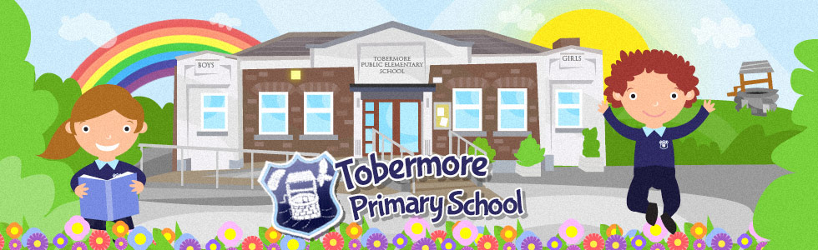

To all the Boys and Girls,
We are really looking forward to having you all back to school at the end of August. We will have lots of fun together. For this new academic year you will have your very own special box or bag to keep all your things in. Here is a list of things that you will need.

Children in Primary 1 & 2
Stationery for the children in year 1 & 2 will be provided and will be stored in their special bag in their classroom. They should however bring a packet of tissues and a bottle of hand sanitiser on their first day.

Children in Primary 3-7
- 2 writing pencils
- A Packet of colouring pencils
- A packet of felt tips (optional)
- 2 rubbers
- 1 sharpener
- 1 tube of Pritt Stick
- 1 packet of tissues
- 1 bottle of hand sanitiser
Please bring these items with you on the first day back.

We hope you have a lovely summer and cannot wait to hear all about it when you return to school. Have lots of fun and see you soon.
Love from
All the teachers at Tobermore Primary School

NB Parents – Due to new ‘Health and Safety Measures’ that are being put in place for our return to school, each child will have to have their own resources to use in class. We are therefore asking each family to provide some basic resources to try and stop the spread of infection. We really appreciate your support with this. If it is not possible for you to provide any of the resources, please do not hesitate to contact us. We will be encouraging your child to wash their hands several times during the school day. If your child has sensitive skin, you may want to send soap that is suitable for them to use. They will keep this in their bag. The school soap does not contain moisturiser so if your child’s hands become dry please feel free to put some hand cream in their school bag. We will be explaining to the children that they cannot share these soaps/creams with other children.
More information will follow about school reopening and different procedures. Please keep an eye on the school website and Facebook Page over July and August.
We hope you all have a lovely summer!

