TOBERMORE
PRIMARY SCHOOL

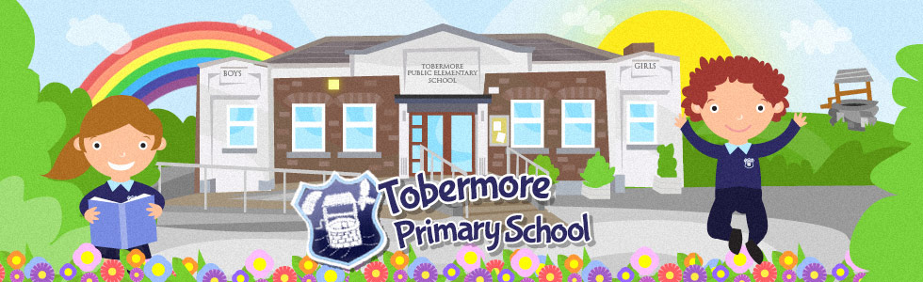

Safe Handling and Reasonable Force Policy

Date Reviewed: April 2019
Due for Review: April 2021

Safe Handling and Reasonable Force Policy

Rationale
The purpose of Tobermore Primary School is the broad and balanced education of each child.

The paramount responsibility of every person connected with the school is the safety and welfare of its children. Through a sense of order and a sense of purpose the care and education of children are made more effective.

In Tobermore Primary School the use of reasonable force with children will always be as a last resort or in an emergency where it is possible that significant harm will occur if action is not taken immediately.

Force will never be used as a punishment.

Situations where reasonable force might be necessary include:
- A pupil attacking another pupil or a member of staff;
- Pupils fighting;
- A pupil causing, or likely to cause damage or injury by rough play, accident, wilful action or misuse of dangerous materials and items;
- A pupil running in a corridor where there is a risk of accident;
- A pupil trying to leave the school;
- A pupil defying repeated instructions to leave a classroom;
- A pupil seriously disrupting a lesson.

It is within this context that safe handling and the use of reasonable force may, on occasions, be necessary.

Aims in Relation to Safe Handling and the Use of Reasonable Force

The aims of this policy are:
- To protect every person in the school community from harm;
- To create a learning environment in which children and adults feel safe;
- To protect all pupils against any form of physical intervention that is unnecessary, inappropriate, excessive or harmful; and
- To provide both teaching and non-teaching staff with guidance relating to circumstances in which reasonable force might be used and how such reasonable force might be applied.

Legislative Framework

This policy has been formulated with due consideration to the following legislation:

- Children (NI) order 1995 duty to protect and child protection responsibilities/fulfilling responsibility;
- UN Convention On The Rights Of The Child 1989 – (12, 16 and 19); Uk 1991;
- Education (NI) Order 1998 (Part ll Article 4 (1);
- Human Rights Act 1998 – Articles 3 and 5 of the European Convention on Human Rights
- Health and safety at Work Act (NI) Order 1978;
- Education and Libraries (NI) Order 2003 – Articles 17, 18, 19

Definition of Safe Handling and Reasonable Force

The use of reasonable force is only lawful if the circumstances warrant it. The degree of force used will be the minimum appropriate to the seriousness of the behaviour or incident that it is intended to prevent. It will be employed calmly and in a professional manner. This might include:
- Physically separating pupils;
- Blocking a pupil’s path;
- Holding;
- Leading a pupil by the arm or hand;
- Shepherding a pupil with a hand on the back or shoulder; or (in extreme circumstances) using more restrictive holds.

Unacceptable and Unreasonable Force

The following uses of force will always be considered unreasonable and therefore will not be used in Tobermore Primary School:
- Holding around the neck;
- Any hold that might restrict breathing;
- Kicking, slapping, poking or punching;
- Forcing limbs against joints;
- Tripping;
- Holding by the hair; and
- Holding the pupil face down on the ground.

Responsibility for Reasonable Force

Teachers and non-teaching staff will only exercise the use of reasonable force in extreme circumstances. In an emergency any member of staff will have the authority to use reasonable force.

The responsibility for use of reasonable force will apply to teachers at the school and to any other members of staff, who with the authority of the principal, have lawful control of pupils – this might include classroom assistants, lunchtime supervisors, caretaker or voluntary helpers accompanying pupils on school visits.

If it is considered likely that a pupil will be sufficiently disruptive to require the regular use of reasonable force (whether for medical, special needs or another reason), the parents/carers will be consulted and an appropriate action plan agreed and reviewed regularly.

Staff will use reasonable force to prevent a pupil from;
- Committing an offence;
- Causing personal injury to, or damage to the property of, another person (including the pupil him/herself); or
- Engaging in any behaviour prejudicial to the maintenance of good order and discipline at the school or among any of its pupils whether during a teaching session or otherwise.

Recording the Use of Reasonable Force

Any occasions where force is used will be recorded in full: the name/s of the pupil/s involved and the time and place of the incident; the names of any witnesses; the reasons for the use of force; an account of what happened including pupil response and the outcome of the incident. This information will be copied to relevant parties.

Complaints

Any complaint following the use of reasonable force will be considered according to the procedures outlined in the school’s policy for dealing with complaints made against a teacher.

